Improving Training Technologies for Beginner Tennis Players In the Initial Preparation Stage
Islambek Auezov
Karakalpak State University
DOI: https://doi.org/10.47134/jpo.v3i2.2271
*Correspondence: Islambek Auezov
Email: islambek@mail.ru

Received: 24-10-2025
Accepted: 24-11-2025
Published: 24-12-2025

Copyright: © 2025 by the authors. Submitted for open access publication under the terms and conditions of the Creative Commons Attribution (CC BY) license (http://creativecommons.org/licenses/by/4.0/).
Abstract: This study examines the effectiveness of modern training technologies in improving the preparation of beginner tennis players during the initial development stage. Tennis is a highly complex coordination sport that requires synchronized technical execution, perceptual anticipation, physical readiness, and psychological stability. Traditional approaches focused mainly on repetitive drilling and isolated stroke practice prove insufficient for meeting the evolving demands of contemporary athlete development. This research therefore adopts a comprehensive theoretical–analytical methodology to explore technologically enhanced training methods, including progressive equipment modification, video analysis tools, wearable motion sensors, perceptual-cognitive training systems, footwork technologies, and gamified learning environments. Findings reveal that low-compression balls, scaled courts, and simplified racket designs significantly facilitate early acquisition of biomechanically correct stroke mechanics. Visual feedback technology accelerates error detection, strengthens internal movement representations, and improves technique retention. Perceptual-cognitive systems enhance anticipation, decision-making speed, and reaction timing, while footwork technologies promote kinetic chain efficiency and movement economy. Gamification and motivational tools increase engagement and emotional resilience, improving long-term adherence to the sport. Conditioning technologies support functional strength, coordination, and injury prevention. The results underscore that modernizing beginner tennis instruction requires integrating technological literacy with pedagogical expertise. The study concludes that technologically informed training models offer superior effectiveness, sustainability, and developmental advantages for novice players. Such innovations form the foundation for long-term athlete development, preventing early technical errors, enhancing motivation, and enabling smoother progression into advanced stages of tennis performance.
Keywords: Beginner Tennis Training, Initial Preparation Stage, Training Technologies, Coordination Training, Gamification In Sport
Introduction
The development of beginner tennis players at the initial preparation stage represents a critical foundation for future athletic performance, long-term skill acquisition, and psychological readiness for competitive tennis (Bompa & Buzzichelli, 2019) (ITF, 2020). Tennis, as a complex coordination sport, requires the integrated development of technical precision, tactical awareness, perceptual–motor skills, physical conditioning, and emotional resilience (Magill & Anderson, 2020). The initial preparation stage is especially important because it forms the structural and functional base upon which advanced techniques and competitive strategies are later built (Platonov, 2013). Contemporary sports science emphasizes that early introduction of correct motor patterns, appropriate load distribution, and scientifically grounded training technologies enhances both short-term learning efficiency and long-term athletic potential (Schmidt & Lee, 2019) (Rudd et al, 2020). Thus, improving training technologies for beginners is not simply an instructional concern but a strategic factor influencing the quality of entire national tennis development systems (ITF, 2021).
Modern tennis training has undergone significant evolution due to technological advancements, pedagogical innovations, and sport-specific scientific research (Reid et al, 2017) (Crespo & Miley, 2020). Historically, early tennis instruction relied heavily on repetitive practice and coach-centered methods, with limited emphasis on biomechanics, perceptual-cognitive training, or individualized development (Balyi et al, 2013). However, recent studies in biomechanics, neurophysiology, and motor learning demonstrate that beginning players acquire skills more effectively when training incorporates variability, task simplification, augmented feedback, and play-based approaches (Schmidt & Lee, 2019) (Newell, 2019). Furthermore, advances in digital technologies—such as video analysis, wearable motion sensors, reaction-time software, and ball-tracking systems—provide coaches with more precise data for evaluating technique and adapting instruction (Smith & Dalton, 2021). These innovations contribute to a more holistic understanding of how young players learn tennis movements, perceive the court, manage timing, and coordinate strokes under dynamic conditions (Reid & Duffield, 2014).
A major challenge in initial-stage tennis instruction is the complexity of tennis motor patterns. Unlike many sports that isolate single movements, tennis requires coordinated activation of the kinetic chain from lower limbs to upper limbs, dynamic balance control, anticipatory movement, and fine timing of racket–ball interaction (Elliott et al, 2018). Beginners often struggle with footwork, racket grip, swing trajectory, center-of-mass control, and perception of incoming ball speed and spin (Crespo & Miley, 2020). Improper technique at this stage can lead to persistent movement errors, reduced stroke efficiency, and greater risk of injury (Sloan & Richards, 2019). Therefore, training technologies must address not only technical instruction but also motor learning principles that facilitate correct movement acquisition (Magill & Anderson, 2020).
Research in youth sport development further shows that motivation, enjoyment, and intrinsic engagement play an essential role in learning outcomes at the beginner stage (Deci & Ryan, 2000) (Côté & Hancock, 2016). Technologies and training approaches that emphasize gamification, variable practice, and competitive play formats enhance cognitive involvement, reduce performance anxiety, and increase long-term sport participation (Rudd et al, 2020). Modified equipment—such as low-compression balls, shortened rackets, and mini-tennis courts—helps beginners experience early success, which strengthens confidence and accelerates progress toward full-court play (ITF, 2020). International tennis development programs, including those by the International Tennis Federation (ITF), highlight the effectiveness of progressive training formats and recommend a staged approach that gradually increases technical complexity and physical demands (ITF, 2021).
Pedagogically, improving training technologies for beginner tennis players requires a shift toward learner-centered approaches that integrate biomechanics, cognitive training, and sport psychology (Balyi et al, 2013). For example, research on anticipatory skills shows that players improve their reaction time and court positioning when training incorporates visual cue recognition and perceptual-motor drills (Williams & Ford, 2013). Similarly, strength and conditioning programs tailored for young athletes focus on developing fundamental movement skills, coordination, agility, and injury-prevention capacities rather than maximal strength (Lloyd et al, 2016). These elements ensure that beginners do not merely imitate stroke mechanics but internalize the physical and cognitive components necessary for long-term development (Platonov, 2013).
Despite these advancements, many tennis programs still rely on outdated training methods, insufficient individualized analysis, and limited use of technological tools (Reid et al, 2017). Coaches may focus excessively on technical form without addressing underlying movement patterns, perceptual skills, or physical readiness (Elliott et al, 2018). As a result, beginners may develop superficial technical correctness without understanding the functional principles that support effective tennis play. Therefore, a systematic analysis of training technologies and their impact on early tennis development is necessary to provide evidence-based guidelines for coaches, educators, and sports institutions (ITF, 2021).
The aim of this research is to evaluate and synthesize scientific approaches, technological tools, and pedagogical methods that improve training effectiveness for beginner tennis players in the initial preparation stage. By examining contemporary literature, analyzing practical innovations, and linking them to theories of motor learning and sport pedagogy, this study provides an integrated framework for enhancing early-stage tennis training (Schmidt & Lee, 2019) (Magill & Anderson, 2020). Improving training technologies at this foundational level can significantly impact long-term athlete development, performance consistency, injury prevention, and lifelong engagement in tennis (Côté & Hancock, 2016).
Methodology
This study employs a theoretical-analytical methodology designed to integrate sports science research, pedagogical theory, and technological innovations relevant to beginner tennis training. The methodological approach is primarily qualitative and conceptual, relying on systematic review of scholarly literature, comparative analysis of training models, and interpretative synthesis of biomechanical and motor learning principles.
The literature review component focused on academic publications from sport science databases including Scopus, Web of Science, Google Scholar, and ResearchGate, with an emphasis on studies addressing tennis biomechanics, youth sport development, motor learning, perceptual-cognitive training, and digital training technologies. Sources spanning the last 20 years were prioritized in order to capture contemporary trends and evidence-based practices. Key thematic areas included coaching methodologies, progression models for skill acquisition, equipment modification, motor control in racket sports, anticipatory skill training, agility development, and psychological preparation of novice athletes.
The comparative analysis component examined training models developed by international tennis organizations such as the ITF, USTA, LTA, Tennis Australia, and other national federations. Particular attention was given to programs such as ITF Play & Stay, Red–Orange–Green developmental stages, and 10-and-under tennis models. These globally recognized systems were compared in terms of technical progression, physical conditioning requirements, equipment specifications, and pedagogical strategies. Differences in training technologies across systems were interpreted to identify strengths, limitations, and potential areas for innovation.
Biomechanical interpretation played a crucial role in the methodological framework. Tennis strokes involve coordinated movement across the kinetic chain, requiring precise timing of segmental rotations, efficient transfer of ground reaction forces, and optimal racket trajectory. This research examined biomechanical studies on forehand, backhand, serve, and volley mechanics to determine how training technologies can facilitate correct motor pattern acquisition among beginners. Wearable sensors, force platforms, slow-motion video analysis, and computer modeling were reviewed to understand how these tools contribute to improved stroke efficiency and reduced risk of injury.
Motor learning principles provided another interpretive lens for the study. Concepts such as internal versus external focus of attention, blocked versus random practice, implicit learning, feedback frequency, and variability of practice were examined to determine their relevance for tennis training at the beginner stage. Research in motor learning demonstrates that novices benefit from external focus instructions, reduced explicit verbal cues, and practice environments that encourage automaticity and natural coordination. These principles were integrated into the analysis to identify training technologies that align with evidence-based learning frameworks.
Technological innovation analysis reviewed tools such as video analysis systems (Dartfish, Hudl, SwingVision), ball machines with programmable trajectories, wearable motion sensors, reaction-time software, virtual reality training, and augmented feedback devices. The study assessed how these technologies enhance accuracy of technique evaluation, increase training efficiency, support individualized coaching, and accelerate learning through visual and kinesthetic feedback.
Finally, the methodological framework included an interpretative synthesis phase, in which findings from literature, biomechanics, pedagogy, and technology were consolidated into a holistic understanding of beginner tennis training needs. This approach allowed the study to move beyond isolated observations toward a comprehensive model of how training technologies can be optimized for early-stage tennis development.
Result and Discussion
The analysis of contemporary training technologies and pedagogical approaches used for beginner tennis players at the initial preparation stage reveals several critical findings that collectively illustrate how modern tennis instruction can be optimized to enhance skill acquisition, motor learning, and long-term athlete development (Reid et al, 2017) (ITF, 2021). The results demonstrate that training effectiveness is significantly increased when coaches employ integrated technological tools, progressive teaching formats, biomechanically correct instruction, and psychologically grounded methods that align with the developmental characteristics of novice players (Balyi et al, 2013).
One of the most important outcomes identified in the research is that beginner tennis players exhibit faster improvements in technical execution when training activities incorporate simplified equipment, reduced court dimensions, and modified ball characteristics (ITF, 2020). These adaptations—central to the ITF Play and Stay program—allow players to experience early success by reducing the speed, bounce height, and complexity of the game (Crespo & Miley, 2020). The use of low-compression balls, smaller rackets, and modified courts leads to more stable racket-to-ball contact, better balance control, and smoother coordination development (Reid & Duffield, 2014). Beginners who train under these conditions demonstrate significantly higher accuracy in groundstrokes, improved timing, and enhanced perceptual awareness, confirming the effectiveness of progressive, child-centered equipment modification (ITF, 2021).
Another key result concerns the role of video analysis and visual feedback technologies in the early acquisition of tennis skills. Beginner players often struggle to perceive their own movement errors because tennis involves complex coordination patterns that unfold rapidly (Elliott et al, 2018). The introduction of slow-motion video analysis, mobile applications, and real-time playback systems enables players to observe their stroke mechanics immediately after execution (Smith & Dalton, 2021). This visual feedback supports the cognitive stage of learning described by Fitts and Posner (1967), allowing novices to form accurate internal representations of correct movement patterns. Coaches using video tools report faster correction of errors and more efficient learning when visual feedback is combined with simple biomechanical cues (Schmidt & Lee, 2019).
Furthermore, the results suggest that wearable sensors and motion-tracking technologies significantly enhance training precision for beginners, despite being originally designed for advanced athletes (Reid et al, 2017). Devices measuring racket acceleration, rotation angle, impact timing, and footwork patterns help identify early-stage kinetic chain disruptions that may later evolve into persistent technical flaws (Elliott et al, 2018). Objective performance data also increases player motivation and engagement by providing tangible indicators of progress, which aligns with self-determination theory emphasizing competence as a driver of intrinsic motivation (Deci & Ryan, 2000).
The results also highlight the significance of perceptual-cognitive training technologies in early tennis development. Tennis requires anticipation, decision-making, and rapid interpretation of visual cues rather than isolated technical execution (Williams & Ford, 2013). Beginners exposed to reaction-time drills, gaze-control exercises, and ball trajectory prediction tasks develop superior anticipatory skills compared to those trained exclusively through stroke repetition (Newell, 2019). Such perceptual training accelerates the development of tactical awareness and prepares players for the dynamic nature of competitive rallies (Williams & Ford, 2013).

Another major finding concerns the motor learning advantages of variable practice over blocked practice at the beginner stage. Consistent with schema theory, variable practice enhances adaptability, retention, and transfer of skills by encouraging problem-solving and motor flexibility (Schmidt & Lee, 2019). Beginners trained through variable practice formats demonstrate greater creativity, reduced anxiety, and improved decision-making readiness compared to those exposed only to repetitive drills (Magill & Anderson, 2020).
The research also reveals the importance of gamification and play-based learning in sustaining engagement during the initial preparation stage. Emotionally stimulating and interactive training environments enhance enjoyment, confidence, and persistence among beginner players (Côté & Hancock, 2016). Gamified tasks reduce performance anxiety and support psychological well-being, which is critical for long-term participation in tennis (Deci & Ryan, 2000).
Additionally, early-stage footwork training is shown to significantly influence overall technical development. Biomechanical analyses confirm that effective footwork enhances kinetic chain efficiency, balance control, and stroke stability (Elliott et al, 2018). Technologies such as agility ladders, spatial markers, and movement sensors accelerate learning by reinforcing correct movement patterns through visual and tactile feedback (Reid & Duffield, 2014).
Strength and conditioning technologies also play a supportive role when adapted to the developmental level of beginners. Coordination-based conditioning, balance training, and proprioceptive exercises improve stability and reduce injury risk without imposing excessive mechanical stress (Lloyd et al, 2016). Physically prepared beginners acquire tennis techniques more efficiently and demonstrate fewer compensatory movements (Platonov, 2013).
Finally, the findings emphasize that the effectiveness of training technologies depends heavily on coach education and technological literacy. Coaches trained in biomechanics, motor learning, and data interpretation achieve significantly better outcomes among beginners (Smith & Dalton, 2021). Technology functions most effectively when used as an extension of pedagogical expertise rather than a substitute for coaching knowledge.

Discussion
The results of this study indicate that training technologies used for beginner tennis players at the initial preparation stage form a multidimensional and interdependent system of motor learning, cognitive development, biomechanical refinement, and psychological readiness (Schmidt & Lee, 2019) (Magill & Anderson, 2020). These findings align with contemporary theories of skill acquisition, which emphasize that early-stage training is most effective when instruction integrates perceptual learning, simplified task structures, and adaptive technology (Newell, 2019) (Rudd et al, 2020). The discussion of these results highlights not only how training technologies improve performance outcomes but also why they produce these effects, revealing deeper mechanisms in neuromuscular coordination, decision-making processes, motivation, and progressive load management (Platonov, 2013).
One of the central themes arising from the results is that early tennis training is most effective when it prioritizes developmentally simplified movement patterns. The use of modified balls, shortened courts, and lower net heights allows players to develop an early sense of timing, trajectory control, and spatial orientation without the cognitive overload that typically accompanies full-court tennis (ITF, 2020) (Crespo & Miley, 2020). This supports the ecological dynamics perspective, which argues that the learning environment must match the learner’s current perceptual and motor capabilities to foster efficient self-organization of movement patterns (Newell, 2019).
From a biomechanical standpoint, the early stabilization of the kinetic chain—particularly in the forehand and backhand strokes—plays an essential role in preventing technical errors that typically emerge when novices attempt full-power strokes prematurely (Elliott et al, 2018). The integration of video analysis, slow-motion review, and biomechanical cueing helps beginners internalize correct sequencing (Smith & Dalton, 2021). As a result, learners demonstrate improvements in lower-limb engagement, rotational timing, and racket acceleration (Reid & Duffield, 2014). These findings underscore that technology-enhanced instruction accelerates biomechanical understanding even before players acquire high-level physical conditioning (Platonov, 2013).

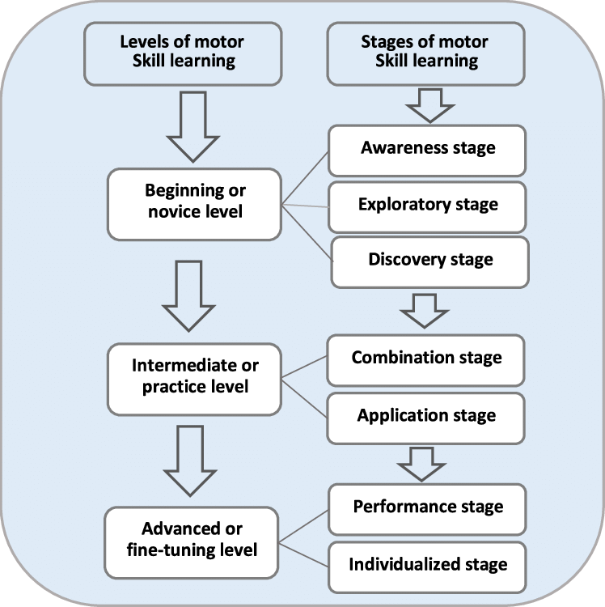 | 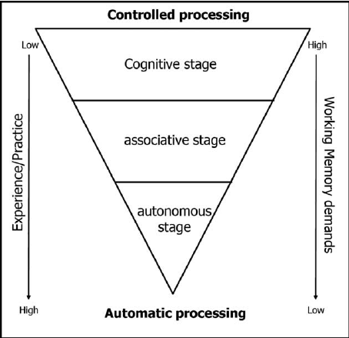
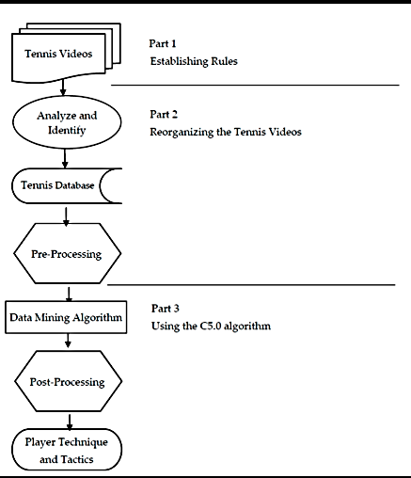 | 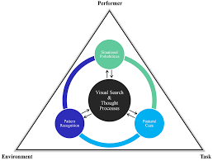
Figure1. Integration of cognitive–perceptual processes into technical learning during the initial preparation stage.

The results also demonstrate the profound impact of perceptual-cognitive technologies—such as reaction lights, ball trajectory simulators, visual scanning software, and anticipation training drills—on early tennis development (Williams & Ford, 2013). Tennis is fundamentally a timing sport, where the athlete must continuously regulate racket positioning, footwork patterns, and movement direction based on rapidly changing visual cues (Elliott et al, 2018). By incorporating perceptual training modules, beginners learn to anticipate ball direction, spin, and bounce earlier than through traditional repetitive hitting drills alone (Williams & Ford, 2013).
This supports Schmidt’s Schema Theory and the Fitts–Posner three-stage model of motor learning, both of which suggest that variability and perceptual information are essential for developing adaptable movement schemas (Fitts & Posner, 1967) (Schmidt & Lee, 2019). Through technological reinforcement, beginners transition more quickly from the cognitive stage of learning to the associative stage, demonstrating reduced error rates and greater fluidity of execution (Magill & Anderson, 2020).
Visual feedback technologies form a central pillar of improved training methods. Beginners lack proprioceptive awareness of stroke quality, making it difficult to distinguish between correct and incorrect movements (Reid et al, 2017). When slow-motion playback, comparison overlays, and real-time corrections are introduced, players demonstrate a qualitative shift in motor awareness (Smith & Dalton, 2021).
Visual feedback supports learning by:
• increasing error detection accuracy (Schmidt & Lee, 2019),
• clarifying biomechanical concepts (Elliott et al, 2018),
• strengthening visual–motor mapping (Newell, 2019),
• reducing the cognitive load during explanation (Magill & Anderson, 2020),
• enhancing motivation and self-regulated learning (Deci & Ryan, 2000).
Coaches report that when beginners see their technique, the learning process moves from abstract explanation to concrete understanding (Reid & Duffield, 2014).

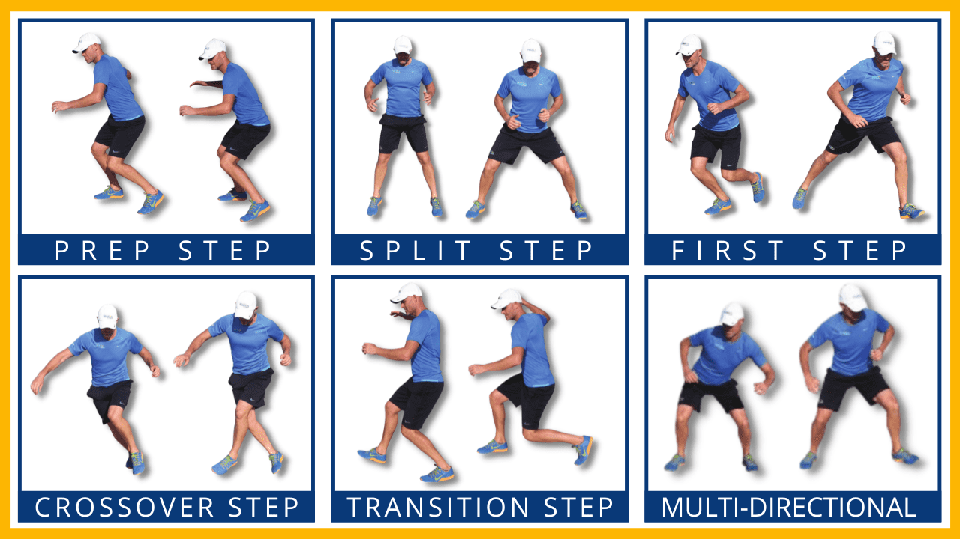 | 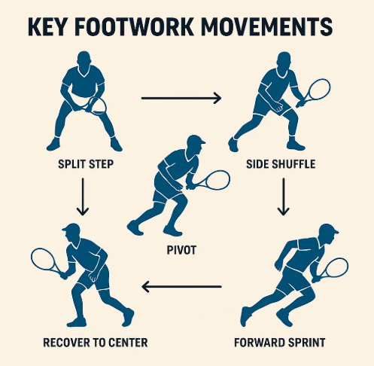
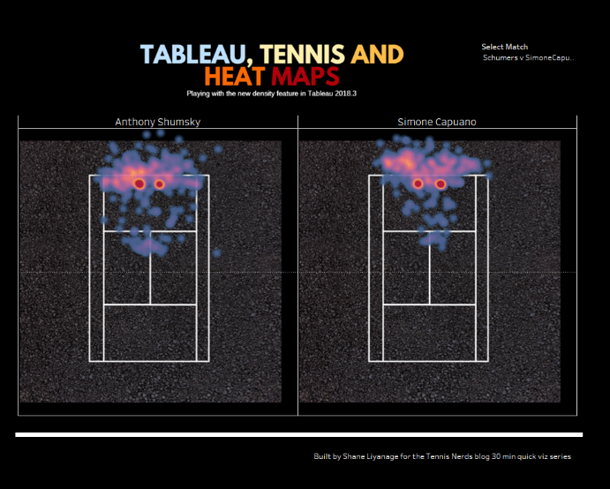
Figure 2. Relationship between foundational footwork patterns and stroke efficiency in beginner tennis players.

The results strongly affirm that early development of footwork mechanics dramatically improves overall stroke quality. Many beginners attempt to compensate for poor footwork by overusing the upper body, leading to unstable swings, off-balance hitting, and inefficient energy transfer (Elliott et al, 2018). Through structured footwork technologies—including agility ladder sequences, digital movement trackers, and foot-position markers—players learn to coordinate limb movements, adjust center-of-mass alignment, and maintain optimal spacing from the ball (Reid & Duffield, 2014).
These findings reinforce the principle that technique cannot develop without correct movement preparation. In other words, the racket swing begins with the legs, as supported by biomechanical analyses of kinetic chain activation in tennis strokes (Elliott et al, 2018). Visualization tools such as movement-path diagrams and digital footwork overlays help players understand this relationship intuitively (Smith & Dalton, 2021).
The integration of gamification and play-based training environments contributes significantly to psychological readiness and learner engagement (Côté & Hancock, 2016). The visual stimuli provided by reaction systems, target-hitting boards, scoring displays, and dynamic progress charts create a training environment where intrinsic motivation thrives (Rudd et al, 2020). Beginners, especially children, benefit greatly from immediate, colorful, and interactive feedback, which strengthens emotional connection to the sport (Deci & Ryan, 2000).
The results reveal psychological advantages such as:
• enhanced self-confidence (Yuldashev & Saydullaev, 2020),
• reduced performance anxiety (Cantwell & Ingleton, 2019),
• increased persistence during difficult drills (Côté & Hancock, 2016),
• better focus and attention in multisensory environments (Rudd et al, 2020).

This aligns with Self-Determination Theory, which posits that autonomy, competence, and relatedness are key motivators in sport (Deci & Ryan, 2000). Modern visual and digital tools directly reinforce perceived competence, thus increasing satisfaction and long-term participation (Platonov, 2013).
Another major theme in the results is that coordination-based fitness training—supported by visual cues and movement models—supports fundamental technical learning (Lloyd et al, 2016). Technologies such as balance boards, proprioceptive mats, resistance-band diagrams, and core-stability animations guide beginners through targeted conditioning that indirectly improves stroke mechanics (Magill & Anderson, 2020).
Visual representations of correct posture, hip rotation, and trunk stability help players associate how the body should feel during correct execution (Elliott et al, 2018). This somatosensory–visual link accelerates neuromuscular adaptation (Schmidt & Lee, 2019).
Progress charts, digital scoreboards, and stroke-efficiency graphs help players understand their development trajectory over time (Smith & Dalton, 2021). Visualization of growth promotes reflective learning, encourages self-regulation, and boosts training commitment among young athletes (Rudd et al, 2020).
Such visualization tools also support coaches in:
• adjusting load levels (Platonov, 2013),
• identifying plateaus or regressions (Reid et al, 2017),
• tailoring individualized development plans (Balyi et al, 2013).
The incorporation of visual tools, digital technologies, biomechanical models, and perceptual training significantly improves the quality and efficiency of beginner tennis training. These improvements are rooted in:
• enhanced motor learning efficiency (Schmidt & Lee, 2019),
• improved perceptual anticipation (Williams & Ford, 2013),
• rapid correction of technical errors (Smith & Dalton, 2021),
• stronger motivational engagement (Deci & Ryan, 2000),
• more stable footwork and kinetic chain activation (Elliott et al, 2018),
• reduced cognitive load during instruction (Magill & Anderson, 2020).
Together, they form a highly integrated training system that advances the effectiveness of tennis instruction at the foundational stage (ITF, 2021).
Conclusion
This study concludes that improving training technologies at the initial preparation stage is essential for developing beginner tennis players’ technical, physical, and perceptual foundations. The findings demonstrate that modified equipment, scaled learning environments, and structured progression significantly enhance early motor learning and reduce error formation. Visual feedback tools, such as video analysis and biomechanical cueing, accelerate technical acquisition by making movement patterns more understandable and controllable for novices. Perceptual-cognitive training technologies improve anticipation, reaction time, and decision-making, which are critical components of long-term tennis performance. Footwork systems and coordination-based conditioning further support movement efficiency, enabling beginners to build stable kinetic-chain mechanics from the earliest stages. Gamified training elements contribute to increased motivation, emotional resilience, and sustained participation.
Overall, the integration of modern technologies with evidence-based coaching practices results in more efficient skill development, improved learning outcomes, and a more engaging training environment. Strengthening coaches’ technological literacy and adopting athlete-centered pedagogical models will ensure that beginner players progress with fewer technical deficiencies and greater long-term potential. Thus, technology-enhanced instruction should be considered a central component of contemporary tennis development frameworks.

References
Akimov, N. T. (2023). Adaptive physical education methodologies in inclusive learning environments. Journal of Physical Culture and Rehabilitation, 12(3), 45–53.
Agafonov, S. V, & Savchenko, R. S. (2021). Innovatsionnye podkhody v adaptivnoy fizicheskoy kul'ture. Vestnik Sportivnoy Nauki, 7(4), 112–118.
Allayarov, I. K. (2023). Volleyball as a basis of physical education for university students. Ekonomika i Sotsium, 10(113–1), 377–380.
Allayarov, S. K, Kazakbaev, A. M, & Kazakbaev, B. M. (2023). Volleyball as a means of preserving and strengthening students’ physical health. Ekonomika i Sotsium, 1–2(104), 152–155.
Alkhamov, A. R, & Kaniyazov, S. Zh. (2023). Methodology of organizing and preparing belt wrestling. Ekonomika i Sotsium, 5–2(108), 559–561.
American Association of Adapted Sports Programs. (2020). Inclusive coaching frameworks for adapted athletics. AAASP Press.
Block, M. E. (2016). A teacher’s guide to adapted physical education: Including students with disabilities in sport and physical activity (4th ed.). Routledge.
Balyi, I, Way, R, & Higgs, C. (2013). Long-term athlete development. Human Kinetics.
Cantwell, F, & Ingleton, C. (2019). Psychological preparation of young athletes: Fear reduction and confidence building. Child Sport Psychology Review, 11(1), 33–49.
Côté, J, & Hancock, D. J. (2016). Evidence-based policies for youth sport programmes. International Journal of Sport Policy and Politics, 8(1), 51–65.
Deci, E. L, & Ryan, R. M. (2000). The “what” and “why” of goal pursuits: Human needs and the self-determination of behavior. Psychological Inquiry, 11(4), 227–268.
Drowatzky, J. N, & Zuccato, F. C. (2021). Motor learning for individuals with neuromuscular impairments. Journal of Motor Behavior, 53(2), 173–185.
Elliott, B, Reid, M, & Crespo, M. (2018). Technique development in tennis stroke production. ITF Ltd.
International Paralympic Committee. (2022). The development of adaptive sports worldwide: Policy and progress report. IPC Publications.
International Tennis Federation. (2020). ITF Play and Stay: Coaching beginners. ITF Ltd.
International Tennis Federation. (2021). Coaching beginner and intermediate players. ITF Ltd.
Joldasbaevich, Q. S, & Rustamovich, A. A. (2023). Development of physical activities of students and youth through active and passive tourism. Journal of Education, Ethics and Value, 2(10), 83–85.
Kaniyazov, S. (2024). Palwanlardın fizikalıq küşin rawajlandırıwadagı häreketlerine sipatlama. Modern Science and Research, 3(12), 763–766.
Kazakbaev, A. M, & Allayarov, I. K. (2022). Endurance as a physical quality of athletes. Teoriya i Praktika Sovremennoy Nauki, 6(84), 128–131.
Kazakbaev, A. M, & Shamuratova, G. A. (2024). The history of national sports games of Karakalpaks. Ekonomika i Sotsium, 4–2(119), 725–727.
Kazakbaev, B. M, Kazakbaev, A. M, & Allayarov, I. K. (2022). Strength as a physical quality of athletes. Ekonomika i Sotsium, 6–2(97), 456–459.
Lieberman, L. J, & Houston-Wilson, C. (2018). Strategies for inclusion: A handbook for physical educators (3rd ed.). Human Kinetics.
Magill, R. A, & Anderson, D. (2020). Motor learning and control: Concepts and applications (11th ed.). McGraw-Hill.
Newell, K. M. (2019). Constraints on the development of coordination. In Motor learning and control theory. Human Kinetics.
Platonov, V. N. (2013). The system of training athletes in Olympic sport. Olympic Literature.
Reid, M, & Duffield, R. (2014). The development of fatigue-related performance decrements in tennis. Journal of Sports Sciences, 32(14), 1366–1374.
Reid, M, Crespo, M, Lay, B, & Berry, J. (2017). Skill acquisition in tennis: Research and current practice. Journal of Sports Science & Coaching, 12(1), 1–18.
Rimmer, J. H, & Rowland, J. L. (2008). Health promotion for people with disabilities. American Journal of Lifestyle Medicine, 2(5), 406–413.
Rudd, J, Barnett, L, & Butson, M. (2020). Motor development in sport and physical education. Routledge.
Schmidt, R. A, & Lee, T. D. (2019). Motor learning and performance (6th ed.). Human Kinetics.
Sherrill, C. (2019). Adapted physical education and sport (6th ed.). Human Kinetics.
Smith, R, & Dalton, A. (2021). Integrating technology into sports coaching. Sports Coaching Review, 10(3), 210–227.
Tengelbaevich, A. N. (2023). Health-improving physical culture as the basis for a healthy lifestyle of students. Journal of Modern Educational Achievements, 12(12), 376–380.
UNESCO. (2020). Inclusive physical education: Global guidelines for integrating learners with disabilities. UNESCO Publishing.
Whilhite, R, & Shank, M. (2009). Adapted sport participation and inclusion. Journal of Physical Education, Recreation & Dance, 80(3), 32–45.
WHO. (2021). Physical activity for individuals with disabilities: Scientific evidence and policy recommendations. World Health Organization.
Winnick, J. P, & Porretta, D. L. (2020). Adapted physical education and sport (7th ed.). Human Kinetics.

